# **FDs and Normalization Practice Questions**

**Question 1: Prove or disprove the following inference rules for functional dependencies**(Note: A proof can be made using inference rules.

A disproof is performed by giving a counter example that is you have to come up with a relational instance that satisfies the conditions and functional dependencies in the L.H.S of the inference rule and does not satisfy the dependencies on the R.H.S.)

OR you can disprove using closure.

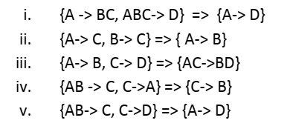

**Question 2: Consider a relation R(A,B,C,D,E), with FDs AB → C, C → A, C → BD, D → E.**

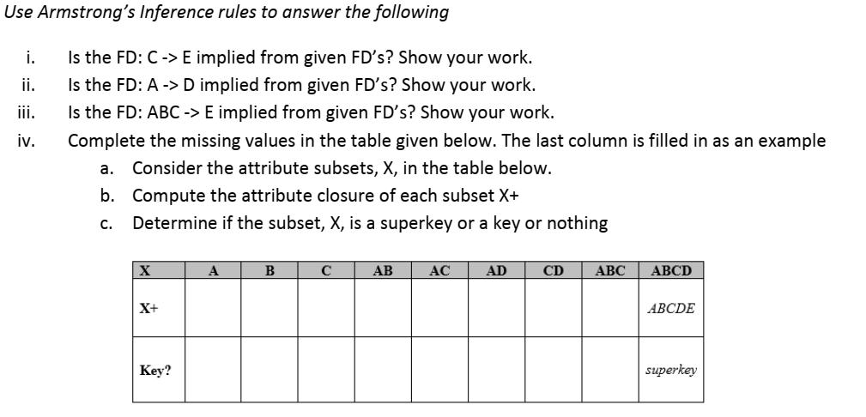

**Question 3: Find out that the following set of functional dependencies for the a relation R(V,W,X,Y,Z)  
are equivalent or not.**1. V->W, VW->X, Y->VX, Y->Z  
2. V->WX, Y->VZ

**Question 4: Consider the relation R(A,B,C,D,E,F,G,H,I) and a set of functional dependencies:**

FD’s = {AB → CD, A → E, B → FH, C → G, D → B, G → C,H → I}

|  |  |
| --- | --- |
| i.  ii. | Find Key for the above relation R? Find a minimal cover for the above set of FD’s? |

**Question 5: Consider the following relation R(A,B,C,D)**

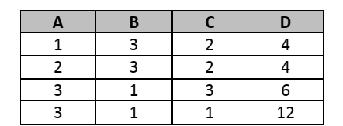

**Which of the following dependencies hold on R? Explain your answer.**

i) A->B  
ii) A->CD  
iii) B->A  
iv) BCD->A  
v) AC-> B  
vi) BC->D  
vii) C->B

**Question 6:** Consider a relation R(A,B,C,D,E). The following set of five functional dependencies hold  
on R:  
FDs= {A -> D , AB -> C, B -> E, D -> C, E -> A}  
We decompose relation R so that one of the new relations is R1(A,B,C). Given the complete set of FD's  
that hold on R1, also specify all keys for R1. Don't forget that a key must be *minimal.*

**Question 7:** Consider a relation with schema R(A,B,C,D,E,F) and functional dependencies  
FDs = {A-> F, A->C, C->D, B->E}

|  |
| --- |
| 1. What normal form is the relation in? Explain your answer 2. Apply normalization until you cannot decompose the relations further. State the reasons for each decomposition |

**Question 8:**

The following attributes represent data about a movie copy at a video rental store. Each movie is identified by a movie number and has a title and information about the director and the studio that produced the movie. Each movie has one or several characters, and there is exactly one actor playing the role of each of the characters (but one actor can play multiple roles in each of the movies). A video store has multiple copies of the same movie, and the store differentiates copies with a movie copy number, which is unique within a single movie but not unique between different movies. Each movie copy has a rental status and return date; in addition, each copy has a type (VHS, DVD, or Bluray). The rental price depends on the movie and the copy type, but the price is the same for all copies of the sametype.

The attributes are as follows:

|  |
| --- |
| **Movie Nbr, Title, Director ID, Director Name, Studio ID, Studio Name, Studio Location, Studio CEO,**  **Character, Actor ID, Name, Movie Copy Nbr, Movie Copy Type, Movie Rental Price, Copy Rental Status, Copy Return Date** |

A sample data set regarding a movie would be as follows (the data in the curly brackets are character/actor data, in this case for four different characters):

|  |
| --- |
| 567, ”It’s a Wonderful Life”, 25, “Frank Capra”,234, “Liberty Films”, “Hollywood, CA”, “Orson Wells”, {“George Bailey”, 245, “James Stewart” | “Mary Bailey”, 236, “Donna Reed” | “Clarence Oddbody”, 765, “Henry Travers” | “Henry F. Potter”, 325, “Lionel Barrymore” }, 5434, “DVD”, 2.95, “Rented”, “12/15/2010” |

**Based on this information**,

1. Identify the functional dependencies between the attributes.
2. Identify the reasons why this set of data items is not in 3NF and tell what normal form (if any) it is in.
3. Present the attributes organized into 3NF relations that have been named appropriately.

**BOOK: the complete BOOK**

**Chapter 3**

**Examples and**

**Exercise problems**

**BOOK: Fundamental of Database system Edition 7th**

**Exercise Questions**

**14.19**

**14.24**

**14.25**

**14.26**

**14.27- till -14.36**